Silent Hoist and Crane Company Material Handling Prize Submission

Economic Time Series Modeling of U.S. Housing Prices

Vikas Garg, Yasin Khan, Shirley Lu, Timothy Roberts, Yi Fan Tang, Wesley Tillu
Project Advisors: Prof. David Matteson and Prof. David Ruppert

Introduction
The unprecedented rise in housing prices within the United States during the last decade has led to an exponential growth in housing valuations and overall U.S. GDP. This phenomenon combined with reckless lending standards, post deregulation, and rock bottom interest rates fueled the housing bubble and the subsequent recession as we know it today. With the present uncertainty in the housing price market, it’s imperative for financial institutions and hedge funds trading in Mortgage Backed Securities (MBS) and Credit Default Swaps to develop efficient and robust forecasting models to understand the housing price process. More importantly, to be able to predict the evolution of housing prices over a five year horizon with the purpose of devising profitable trading strategies.

As a key driver of mortgage rates and valuation, understanding house price evolution is critical to investing in mortgage backed assets. This project utilizes the state level quarterly Housing Price Index (HPI) data provided by the Office of Federal Housing Enterprise Oversight (OFHEO), which is now the Federal Housing Finance Agency (FHFA), as a measure of movement for single family house prices in the United States. The aim of this study is to investigate the presence of long memory in the HPI index and to model the HPI returns as a proxy for housing prices at the state level. This model could then be used to forecast HPI returns to profitably price and trade MBS.

A two phase approach was adopted to model the HPI returns data. Phase I is dedicated to drift modeling and Phase II is dedicated to modeling the residuals, also referred to as volatility modeling.

Housing Price Economics
In Phase I we explored the relationship between the HPI returns and major economic indicators (predictors) that affect the housing process, in a time series regression framework. The predictors used to model the HPI were population size and growth, median income (proxy for housing affordability), unemployment rate, foreclosures, mortgage originations, 30 year current coupon (proxy for the cost of credit) and building permits issuance (proxy for housing stock). Leading and lagging values of these predictors were used in the regression to capture the true dependence of HPI returns on these indicators.

The variable relationship was investigated to ensure economic sense of the model coefficients. As an example, population size has a positive correlation with HPI because for a given increase in population there is a positive demand shock for housing. This is a reasonable rule-of-thumb to use, although at times it can have limitations. For example, building permits do not always lead to housing starts and completions, depending on conditions in the market.

Modeling Methodology
In analyzing each state’s HPI, the response and predictors were transformed to their simple returns and the data was interpolated from quarterly to monthly frequency. Multiple regression models were developed at the state level for modeling the drift component. Phase II modeling of the residuals was done when autocorrelated residuals were observed after the multivariate regression carried out in Phase I using Auto Regressive Fractionally Integrated Moving Average / Generalized Autoregressive Conditional Heteroskedasticity (ARFIMA/GARCH) models. This time series modeling is done to model the residual autocorrelation, as well as conditional heteroskedasticity if present.

To generate multiple steps ahead forecasts, curve fitting techniques were used for each of the predictors. First, the forecasted estimates of the predictors are generated using these curve fits and these forecasted values are then fed into the HPI forecasting models developed at the end of Phase II.

Additionally, this project investigates the presence of long memory in the housing price process, with a specific focus on long memory in housing price volatility. Research has discovered long memory effects in broad market REITS, and have successfully explained REITS returns in ARFIMA/GARCH framework. Also, stable long-memory parameter estimates across rolling sample periods for securitized US and UK property markets have been discovered, validating our investigation.

Results
Our paper demonstrates the consistency of macroeconomic drivers of housing price drift, as well as a significance presence of volatility clustering and long-memory in housing price returns. We also believe states are susceptible to regime changes and structural breaks as a result of price inflation, which may induce long memory effects in this analysis.

The majority of the states’ simple return series were determined to be stationary based on Augmented Dickey-Fuller and Phillips-Perron test results. Furthermore, the simple returns do not follow a Gaussian distribution and a Box Cox transformation is ineffective in making the return series normal. Some of the states exhibited non-normality, which may be a result of ARCH effects; however, this is remedied by GARCH modeling.

Geweke and Porter-Hudak and Whittle estimators were used for determining the presence of long memory, which was observed in the simple returns of the HPI for multiple states. In analyzing each state’s simple returns, interpolated linearly from quarterly to monthly, and cutting-off data before 1985, we observe adequacy of ARFIMA/GARCH framework. It was speculated that the OFHEO housing price index may have varying degrees of data quality. More specifically, the data collection methods before 1990 may have not been consistent, leading to incorrect index levels. This may be evidenced by the extremely high volatility in early periods of the simple return data up to around 1985.

Results concluded multiple linear regression models with ARFIMA/GARCH error modeling successfully capture the changes in the OFHEO HPI. The residuals of the resulting models were not only stationary, but uncorrelated as well; determined by concluding with the appropriate hypothesis for the Ljung-Box and Augmented Dickey-Fuller tests. The economic predictors were required to have the correct leading or lagging relationship to have significance in the regression. This relationship was determined by visually inspecting the simple returns of the variable plotted with the simple returns of the HPI.
The forecasted economic variables allowed us to forecast changes in the HPI. Back testing of the regression time series model was performed using temporal holdout, where data up to the end of second quarter of 2006 was included in the temporal holdout set and forecasts were generated beyond 2006. Most of the states had excellent forecasts, but a few did not fare well for the entire five year forecast. This may be remedied by improving the multivariate regression model with additional predictors, such as a proxy for short term interest rates or energy prices, as discussed in the next steps section.

Our results also indicate there is a high possibility of co-integration among factors, which needs to be investigated. The similar leading relationship of predictor variables and HPI changes for similar states, i.e. Arizona and California, was indicative of co-integration. Investigation of this will allow for joint modeling of states’ HPI.

Case Study: Arizona
Phoenix and its suburbs are among the hardest hit by the foreclosure crisis. Avondale, just west of Phoenix, doubled in residents between 2000 and 2005. Now residents are unable to sell their houses except at fire-sale prices. In a case study done by the Wall Street Journal, appraisers valued a house at $132,000 for a $103,000 mortgage, sight unseen, before the housing bubble burst. Under foreclosure the house recently sold for $18,000.

Moreover, the state economy has dependence on three industries that led the nation into recession: construction, housing and financial services. Analyst’s forecast an increase in home prices and sales is unlikely to happen until 2012.

Using a multiple regression model with time series analysis, the following model was fit to Arizona:

Drift Equation
Y_{t} = 1.57x_{1,t} + .03x_{2,t} + .02x_{3,t} - 0.28x_{4,t} - .005x_{5,t} + .0174x_{6,t} + r_{t}

Volatility Equation AR(2):
r_{t} = 0.12r_{t-1} + 0.52r_{t-1} + ε_{t}
where:
Yt = Simple Returns of HPI
X_{1,t} = Simple Returns of Median Income (Lead 11 mo.)
X_{2,t} =30 Year Commitment Rate (Lead 6 mo.)
X_{3,t} = Simple Returns of Mortgage Originations (Lead 2 mo.)
X_{4,t} = Unemployment Rate (Lead 9 mo.)
X_{5,t} = Simple Returns of Foreclosures (Lead 12 mo.)
X_{6,t} = Simple Returns of Building Permits (Lead 13 mo.)
r_{t} = Phase I Residuals
ε_{t} = Phase II residuals

The plot of the fitted HPI simple returns from this model compared to the actual values is shown in Figure 1.

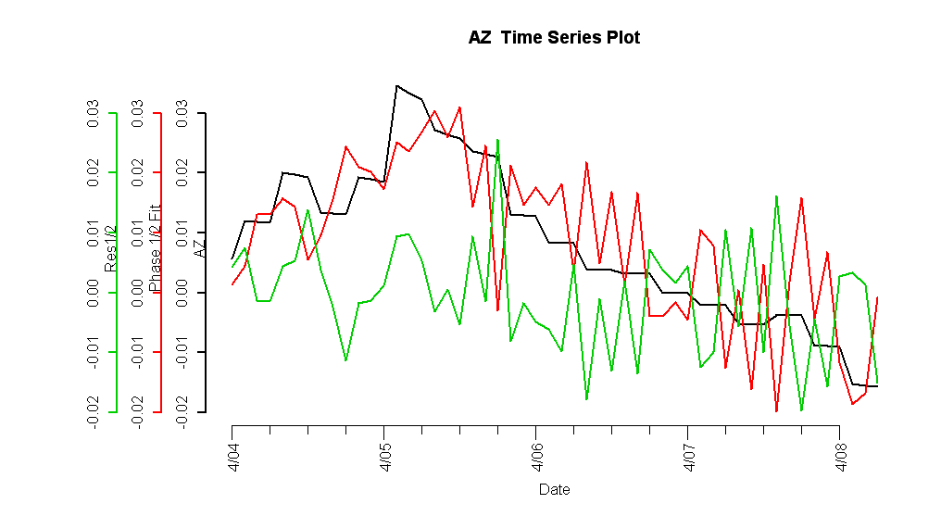
Figure 1: Complete fitted model vs. Arizona HPI and residuals

The economic predictors driving our model were forecasted using curve fitting techniques. Further details of the methodology and an example are discussed in our report. The forecasted values were inputted into the model to predict the simple returns, and the 90% prediction interval was computed. The results for Arizona are shown in Figure 2.

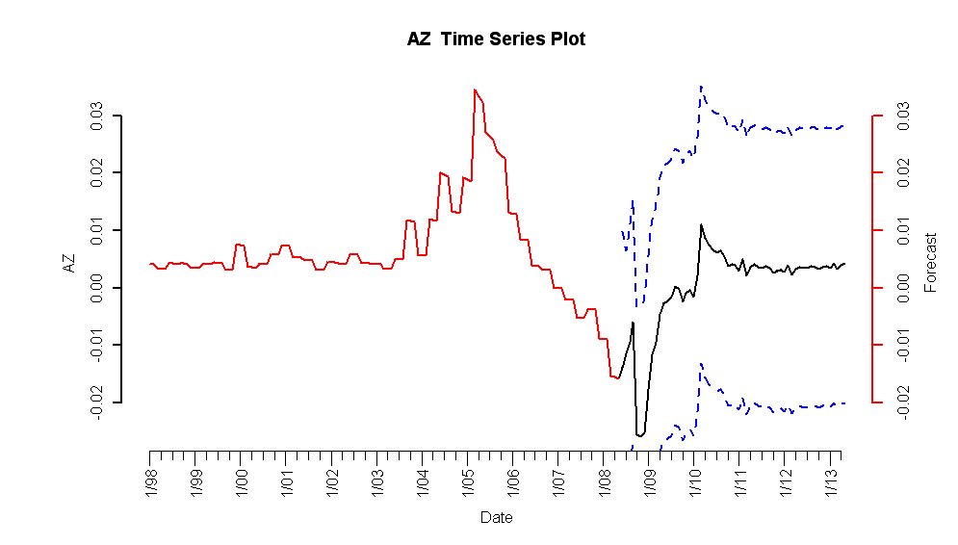
Observed HPI
Forecast
90% Prediction Interval
Figure 2: Arizona five-year forecasted simple returns

The forecasted simple returns are back-transformed to obtain the forecasted HPI values. The results of this are shown in Figure 3. Note that our model was fit with data available through second quarter 2008, since many of our economic predictors are reported on an annual basis. The plotted triangles indicate the observed HPI values for the remainder of 2008, indicating our forecast timing and magnitude is very similar to that of the observed values.

Temporal holdout was performed with coefficients refit as if data was available only through second quarter 2006. Forecasting the economic drivers based only on information available in the middle of 2006, the HPI was forecasted for the next five years. The results are shown in Figure 4, with the observed values plotted.
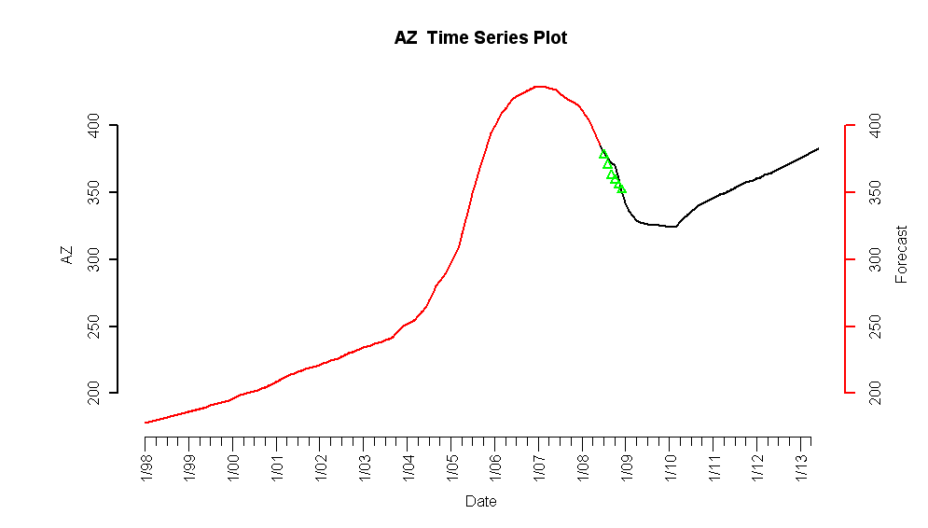
2008 Q3 and Q4 Observed HPI
Observed HPI
Forecast
Figure 3: Arizona five-year forecasted HPI

The interesting conclusion is that the model would have predicted a decline in house prices based simply on economic drivers. The timing and magnitude of changes are captured well by the model, with home prices potentially bottoming out by 2010. More importantly, it provides validity to our modeling and forecasting methodology.

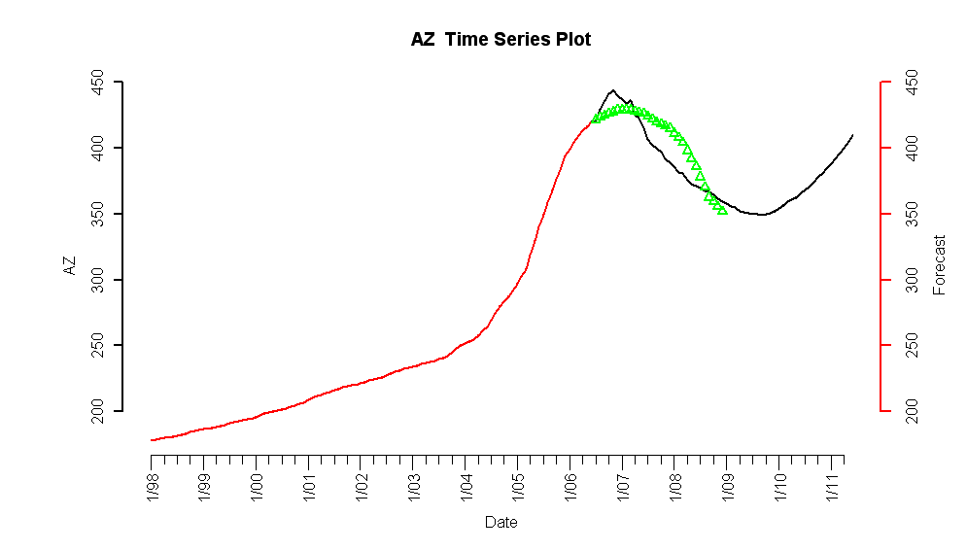
2008 Q3 and Q4 Observed HPI
Observed HPI
Forecast
Figure 4: Arizona five-year temporal holdout forecast

Conclusion
All the predictor variables, used in forecasting the HPI returns, showed a leading relationship with HPI. An interesting consequence of this is that the given model can effectively use the current information on these economic variables to predict the trends in housing price markets in the future. A direct business implication of this is that this model can be used to price assets, which can help in devising beneficial trading strategies, especially in the MBS market.

As a final word, our modeling technique and results have demonstrated the adequacy of our models in explaining the changes in the HPI, as well as forecasting changes. Temporal holdout is an excellent technique for back testing the model accuracy. However, it should be duly noted that models continue to need refinement as new data is observed to ensure optimal forecasting.

